TOKKO - Job Description & Person Specification
KICKSTARTER – Administration and Project Support

JOB DETAILS
Contract Term: | Permanent
Start & End Dates: | 1st February 2022 – 1st August 2022 (6 months)
Hours: | 25
Location: | TOKKO Youth Space, 7, Gordon Street, Luton, Beds. LU1 2QP
Pay: | National Living Wage - £8.91/hr
Reports to: | TOKKO Youth Network Coordinator

ORGANISATION OVERVIEW
TOKKO is a youth charity that is inclusive in its provision, welcoming all young people in Luton and the surrounding area aged primarily between 13 and 19 years (up to 24 years with a disability including diagnosed mental health). The organisation is young person focused and led, putting young people at the heart of everything they do.

TOKKO helps young people to advance in life through support, recreation and leisure; we embed the following 3 core values throughout all our work:

- Work with trust and integrity to support our young people.
- Improve outcomes and aspirations in the lives of our young people.
- Enhance the mental health and wellbeing of our young people.

Through running a range of youth work projects we assist some of the most vulnerable young people in Luton and the surrounding area - providing a safe space and a familiar face. The projects provide opportunities for young people to get involved in positive activities to develop: skills, self-worth, self-belief leading to confidence, self-esteem, promote inclusion and reduce loneliness and isolation amongst young people.

We support young people to deal with and knock down barriers including housing and social issues and provide them with knowledge through informal education; enhancing their life skills, mental health, choices, aspirations and raising their self-worth.

TOKKO ORGANISATIONAL CHART - (Updated 01/2022)
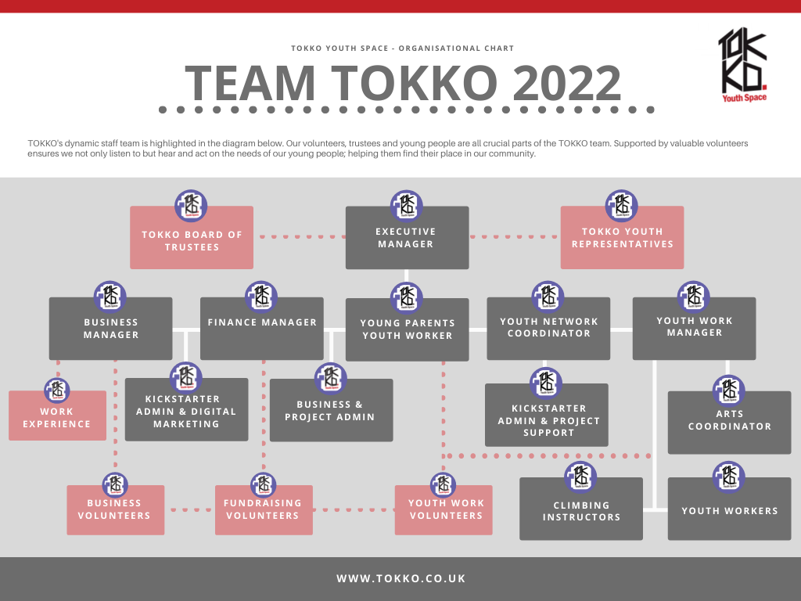

CONTEXT
THIS KICKSTARTER VACANCY IS ONLY OPEN TO YOUNG PEOPLE AGED 16-24 WHO ARE ON UNIVERSAL CREDIT AND MUST DISCUSS THE VACANCY WITH THEIR JOB COACH.

The post holder will be an integral part of the TOKKO team and will be focusing on the efficient provision of customer focused and business / project administration support in order to assist in the end to end process and maintenance of project data and records; whilst being a lead administration support for room bookings.

This post is office based and involves a high level of customer interact both face to face, over the phone and via electronic media (e-mail, website content, social media content.)

POST PURPOSE
Administration and Project Support - Post Overview
General administration tasks, phones, meeting and greeting visitors, using office equipment, sending and receiving e-mails, taking room bookings, supporting reception, data entry, supporting events, supporting youth network officer.

The post holder will be required to provide administration support to enhance delivery of service by the team by:

- Accurate inputting of data onto TOKKO computer systems and key bespoke packages: databases, spreadsheets, schedules etc.
- Liaising with internal and external customers as well as service users.
- Producing pre specified reports from computer systems and distribute as required.
- Supporting the Management Team with items such as completing and sending business and financial paperwork.
- Process bookings quickly and accurately providing excellent customer service.
- Supporting projects with end to end administration.
- Photocopying, answering and making telephone calls, sending/receiving /distributing e-mail messages, opening and distribution of mail and filing.
- Updating web-site information (WordPress) and social media platforms.
- Support providing a reception service.
- Supporting events
- Supporting youth network administration
- Processing and recording petty cash transactions
- Administering loans of equipment and vehicles
- Monitoring building users

The post holder will work to agreed performance targets and standards and will be responsible for identifying trends in their own performance and will be involved in recommending actions to increase the efficiency and productivity of the team and its projects.

The post holder will work with set procedures but may need to work outside of these, where appropriate, in agreement of senior managers.

TOKKO is an equal opportunities employer and is fully committed to safeguarding and promoting the welfare of young people as its utmost priority and expects all staff and volunteers to share this commitment. Health and safety compliance is expected and crucial to all roles. Applicants must be able to provide evidence of having the right to live and work in the UK and will be required to undertake an enhanced criminal background check from the Disclosure & Barring Service.
TOKKO Ltd is registered charity (1156805)

KICKSTARTER – Administration and Project Support

Person Specification
Attribute | Essential (E)  Desirable (D)
Experience
Experience of dealing with front line enquiries from members of the public. | E
Excellent oral and written communication skills, including the ability to communicate with volunteers, young people, supporters and third parties politely and effectively | E
Experience in efficiently prioritising their workload within tight deadlines, able to multi-task and have a flexible approach to working | E
Experience of administrative systems and processes. | E
Business Administration Level 2 qualifications or equivalent | D
Experience of website management | D
Previous experience of working with volunteers and young people. | D
Previous experience working within a charity environment | D
Skills
Excellent organisational skills and ability to plan ahead, keep records, manage deadlines and prioritise workload | E
Great customer service skills, the ability to recognise and meet the needs of customers and to manage expectations when required | E
Excellent written and verbal communication skills | E
Have a high level of attention to detail and precision | E
Proficient in the use of the Microsoft Office suite including the use of Microsoft Teams | E
Good level of IT literacy, including good knowledge of standard business software, Google Suite and social media | E
Ability to understand and manage data (including numerical) and to create reports and analysis | E
Ability to work to procedures, guidelines and targets / deadlines. | E
Able to produce comprehensible reports, statistical information and maintain written work records. | D
Able to work flexible hours to meet the demands of the service including occasional evenings and weekends to support events with prior notice. | D
Personal qualities
Warm, compassionate and empathetic personality with the ability to develop positive relationships with people from all backgrounds | E
Have an understanding and empathy for young people | E
Collaborative and innovative | E
Creative and proactive with a ‘can do’ attitude
Comfortable working in a team environment but also able to work on own initiative | E
Be a good ambassador for TOKKO and comfortable collaborating with external partners | E
Be enthusiastic to learn and take on new challenges | E
Creative in approach with ability to identify and act upon opportunities but with good attention to detail | E
Commitment to ensuring equality of access and treatment to all in employment and service delivery | E
Commitment to upholding the ethos, core values and reputation of TOKKO | E

